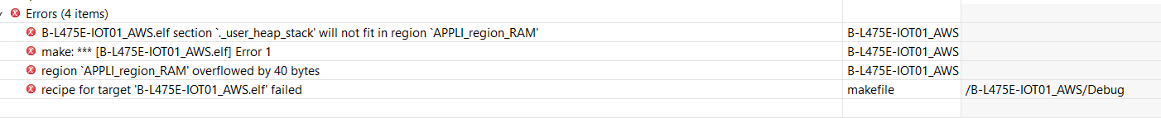

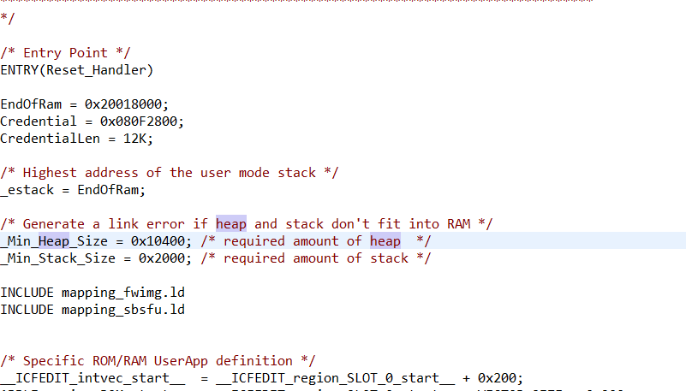

Min_heap_size changed from 0x11000 to 0x10400

Another problem of GCP:

If you want to configure new gcp project and new certificates

1. Import the default gcp project by stm…x-cube-gcp
2. Run it
3. Enter project server address: new project id, new registry, new device
4. Enter Root CA from projects/common/googleiot/comodo_google.pem and enter private key from rsa_private.pem generated. Use the below ssl commands

openssl genpkey -algorithm RSA -out rsa_private.pem -pkeyopt rsa_keygen_bits:2048

openssl rsa -in rsa_private.pem -pubout -out rsa_public.pem

1. Add gps files as mentioned in Luke 430: Copy main.c, msp.c and it.c into application/user and googleiot.c in application/googleiot
2. Add main.h, msp.h, it.h and google_iot.h into project folder B-L475….GoogleIot/Inc